Group member：戴陽(Function Create)、易頡(History Feature)

Environment：Linux

Instructions：

1. gcc z_shell.c -o z-shell.o

2. run ./z-shell.o

3. enter help or other commands

4. enter history to print all the commands entered before including invalid commands

5. exit

6. done

Functions & history feature

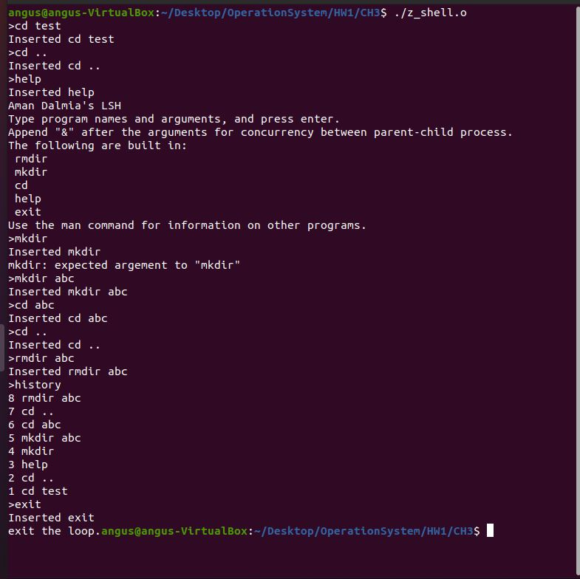

Source code：

#include <sys/types.h>

#include <stdio.h>

#include <unistd.h>

#include <string.h>

#include <stdlib.h>

typedef int bool;

#define true 1

#define false 0

#define LSH_RL_BUFSIZE 1024 /* buffer size for reading user input */

#define LSH_TOK_BUFSIZE 64 /* buffer size for splitting the arguments */

#define LSH_HIST_SIZE 10 /* buffer size for storing history of commands */

#define LSH_TOK_DELIM " \t\r\n\a" /* delimiters for parsing the arguments */

/* global variable to check parent and child process concurrency */

bool conc = false;

/* global variable to point to the last command executed */

int cur_pos = -1;

/* global variable storing the history of commands executed */

char *history[LSH_HIST_SIZE];

int cur_bufsize = LSH_TOK_BUFSIZE;

/* Function declarations for built-in shell commands */

int lsh_rmdir(char **args);

int lsh_mkdir(char **args);

int lsh_cd(char **args);

int lsh_help(char **args);

int lsh_exit(char **args);

/* List of built-in commands, followed by their corresponding functions */

char *builtin_str[] = {

"rmdir",

"mkdir",

"cd",

"help",

"exit"};

int (*builtin_func[])(char **) = {

&lsh_rmdir,

&lsh_mkdir,

&lsh_cd,

&lsh_help,

&lsh_exit};

int lsh_num_builtins()

{

return sizeof(builtin_str) / sizeof(char *);

}

/* Built-in function implementations */

int lsh_mkdir(char **args)

{

if (args[1] == NULL)

{

fprintf(stderr, "mkdir: expected argement to \"mkdir\"\n");

}

else

{

if (mkdir(args[1], 0700) != 0)

{

perror("lsh");

}

}

return 1;

}

int lsh_rmdir(char **args)

{

if (args[1] == NULL)

{

fprintf(stderr, "rmdir: expected argement to \"rmdir\"\n");

}

else

{

if (rmdir(args[1]) != 0)

{

perror("lsh");

}

}

return 1;

}

int lsh_cd(char **args)

{

if (args[1] == NULL)

{

fprintf(stderr, "lsh: expected argument to \"cd\"\n");

}

else

{

if (chdir(args[1]) != 0)

{

perror("lsh");

}

}

return 1;

}

int lsh_help(char **args)

{

int i;

printf("Aman Dalmia's LSH\n");

printf("Type program names and arguments, and press enter.\n");

printf("Append \"&\" after the arguments for concurrency between parent-child process.\n");

printf("The following are built in:\n");

for (i = 0; i < lsh_num_builtins(); i++)

{

printf(" %s\n", builtin_str[i]);

}

printf("Use the man command for information on other programs.\n");

return 1;

}

int lsh_exit(char **args)

{

return 0;

}

/* Launch a program */

int lsh_launch(char **args)

{

pid_t pid, wpid;

int status;

pid = fork();

if (pid == 0)

{ /* child process */

if (execvp(args[0], args) == -1)

perror("lsh");

exit(EXIT_FAILURE);

}

else if (pid > 0)

{ /* parent process */

if (!conc)

{

do

{

wpid = waitpid(pid, &status, WUNTRACED);

} while (!WIFEXITED(status) && !WIFSIGNALED(status));

}

}

else

{ /* error forking */

perror("lsh");

}

conc = false;

return 1;

}

/* Parse input to get the arguments */

char **lsh_split_line(char *line)

{

cur_bufsize = LSH_TOK_BUFSIZE;

int position = 0;

char **tokens = malloc(cur_bufsize * sizeof(char *));

char *token;

if (!tokens)

{

fprintf(stderr, "lsh: allocation error\n");

exit(EXIT_FAILURE);

}

token = strtok(line, LSH_TOK_DELIM);

while (token != NULL)

{

tokens[position] = token;

position++;

if (position >= cur_bufsize)

{

cur_bufsize += LSH_TOK_BUFSIZE;

tokens = realloc(tokens, cur_bufsize * sizeof(char *));

if (!tokens)

{

fprintf(stderr, "lsh: allocation error\n");

exit(EXIT_FAILURE);

}

}

token = strtok(NULL, LSH_TOK_DELIM);

}

if (position > 0 && strcmp(tokens[position - 1], "&") == 0)

{

conc = true;

tokens[position - 1] = NULL;

}

tokens[position] = NULL;

return tokens;

}

/* History of commands */

int lsh_history(char **args)

{

if (cur_pos == -1 || history[cur_pos] == NULL)

{

fprintf(stderr, "No commands in history\n");

exit(EXIT_FAILURE);

}

if (strcmp(args[0], "history") == 0)

{

int last_pos = 0, position = cur_pos, count = 0;

if (cur_pos != LSH_HIST_SIZE && history[cur_pos + 1] != NULL)

{

last_pos = cur_pos + 1;

}

count = (cur_pos - last_pos + LSH_HIST_SIZE) % LSH_HIST_SIZE + 1;

while (count > 0)

{

char *command = history[position];

printf("%d %s\n", count, command);

position = position - 1;

position = (position + LSH_HIST_SIZE) % LSH_HIST_SIZE;

count--;

}

}

else

{

char **cmd_args;

char *command;

if (strcmp(args[0], "!!") == 0)

{

command = malloc(sizeof(history[cur_pos]));

strcat(command, history[cur_pos]);

printf("%s\n", command);

cmd_args = lsh_split_line(command);

int i;

for (i = 0; i < lsh_num_builtins(); i++)

{

if (strcmp(cmd_args[0], builtin_str[i]) == 0)

{

return (*builtin_func[i])(cmd_args);

}

}

return lsh_launch(cmd_args);

}

else if (args[0][0] == '!')

{

if (args[0][1] == '\0')

{

fprintf(stderr, "Expected arguments for \"!\"\n");

exit(EXIT_FAILURE);

}

/* position of the command to execute */

int offset = args[0][1] - '0';

int next_pos = (cur_pos + 1) % LSH_HIST_SIZE;

if (next_pos != 0 && history[cur_pos + 1] != NULL)

{

offset = (cur_pos + offset) % LSH_HIST_SIZE;

}

else

{

offset--;

}

if (history[offset] == NULL)

{

fprintf(stderr, "No such command in history\n");

exit(EXIT_FAILURE);

}

command = malloc(sizeof(history[cur_pos]));

strcat(command, history[offset]);

cmd_args = lsh_split_line(command);

int i;

for (i = 0; i < lsh_num_builtins(); i++)

{

if (strcmp(cmd_args[0], builtin_str[i]) == 0)

{

return (*builtin_func[i])(cmd_args);

}

}

return lsh_launch(cmd_args);

}

else

{

perror("lsh");

}

}

}

/* Execute the parsed arguments */

int lsh_execute(char *line)

{

int i;

// printf("%s\n", line);

char **args = lsh_split_line(line);

if (args[0] == NULL)

{ /* empty command was entered */

return 1;

}

else if (strcmp(args[0], "history") == 0 ||

strcmp(args[0], "!!") == 0 || args[0][0] == '!')

{

return lsh_history(args);

}

cur_pos = (cur_pos + 1) % LSH_HIST_SIZE;

history[cur_pos] = malloc(cur_bufsize * sizeof(char));

char **temp_args = args;

int count = 0;

while (*temp_args != NULL)

{

strcat(history[cur_pos], *temp_args);

strcat(history[cur_pos], " ");

temp_args++;

}

// printf("%s\n", history[cur_pos]);

// history[count] = '\0';

if (cur_pos > -1) // changed to >-1

printf("Inserted %s\n", history[cur_pos]); // changed cur_pos - 1 to cur_pos

for (i = 0; i < lsh_num_builtins(); i++)

{

if (strcmp(args[0], builtin_str[i]) == 0)

{

return (*builtin_func[i])(args);

}

}

return lsh_launch(args);

}

/* Read input from stdin */

char *lsh_read_line(void)

{

cur_bufsize = LSH_RL_BUFSIZE;

int position = 0;

char *buffer = malloc(sizeof(char) * cur_bufsize);

int c;

if (!buffer)

{

fprintf(stderr, "lsh: allocation error\n");

exit(EXIT_FAILURE);

}

while (1)

{

/* Read a character */

c = getchar();

if (c == EOF || c == '\n')

{

buffer[position] = '\0';

return buffer;

}

else

{

buffer[position] = c;

}

position++;

/* If buffer exceeded, reallocate buffer */

if (position >= cur_bufsize)

{

cur_bufsize += LSH_RL_BUFSIZE;

buffer = realloc(buffer, cur_bufsize);

if (!buffer)

{

fprintf(stderr, "lsh: allocation error\n");

exit(EXIT_FAILURE);

}

}

}

}

/* Loop for getting input and executing it */

void lsh_loop(void)

{

char *line;

int status;

do

{

printf(">");

line = lsh_read_line();

status = lsh_execute(line);

free(line);

} while (status);

printf("exit the loop.");

}

int main(void)

{

lsh_loop();

return EXIT_SUCCESS;

}